Operation Manual

Outdoor 700W LED Beam Spot Wash 3in1 Moving Head With CTO & CMY
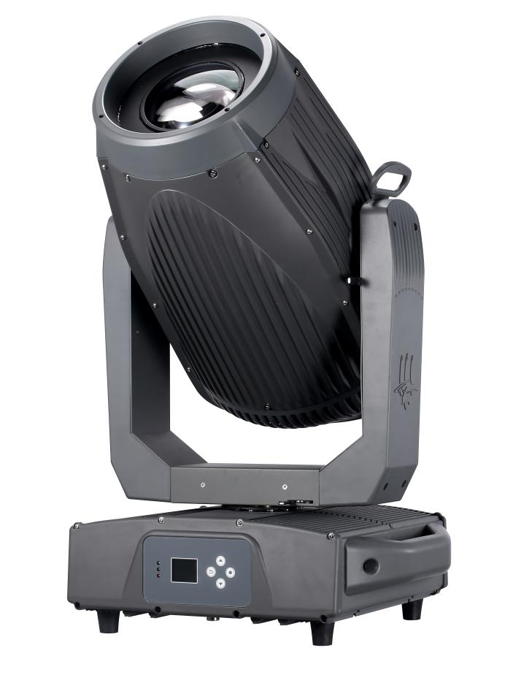
Please read the instructions carefully before use

Orders to record
1. The matters needing attention and installation
1
1.1 Declaration
1
1.2 Maintenance
1
1.3 products
1
1.4 Product Introduction
1
1.5 Signal line connection
2
1.6 installation of lamps and lanterns
2
2. The control panel
4
2.1 the keys that
4
2.2 menu description
5
2.2.1 manually
5
2.2.2 set
6
2.2.3 system
7
3. Channel function
8
Table 3.1
channel
8
4. Common Faults
11

Matters needing attention and matters needing attention and installation
  - The statement
Thank you choose our company's products! This product leaves the factory with good performance and complete packaging. Safe and effective use of this product to you, before you use this product, please read this instruction manual carefully in full. This instruction manual contains important information about installation and use. Please follow the instructions for installation and operation. At the same time, please keep this instruction manual properly for use at any time. Our company does not assume all responsibility for damage to lamps or other properties caused by individuals who do not operate according to the instructions during installation, use or maintenance.
This manual if there is any technical changes without prior notice.

  - maintenance
- Disconnect the power supply before performing maintenance.
- The lamps and lanterns should keep dry, avoid in wet environment.
- The use of intermittent can effectively prolong the life of the lamps and lanterns.
- In order to obtain good ventilation and lighting effects, to pay attention to often clean fan and fan nets and lens.
- Please do not use alcohol and other organic solvents to wipe test lamps shell, lest cause damage.

  - Product matters needing attention
- The lamps and lanterns for professional use only.
- Before running make sure supply voltage power supply voltage is consistent with device requirements.
- Do not place this product in a place where it is easy to loosen or vibrate.
- In use process, such as abnormal lamps and lanterns should stop using the lamps and lanterns in a timely manner.
- In order to ensure the service life of the product, this product should not be placed in a humid or leaky place, and can not work in an environment with a temperature of more than 60 degrees.
- When the bulb is used, the power supply voltage change should not exceed ±10%, the voltage is too high, will shorten the life of the bulb, the voltage is too low, will affect the light color of the bulb.
- After power off, it takes 20 minutes after the use of lamps and lanterns to fully cool down before the use of power again.
- Rotating parts of lamps and lanterns and paste accessories must be inspected regularly, become loose, timely reinforcement shaking, in case of an accident.
- In order to ensure the normal use of this product, please read the instructions carefully.

  - Product introduction
- Light source specification: 700W LED,8000K
- LED life: 20000 hours
- Channel: channel 21
- Voltage: AC 200 v ~ 240 v / 50 ~ 60 hz;
- Strobe: independent strobe, 0.5-20 times/second adjustable color/pattern/effect
- The CTO: independent cuts the CTO
- CMY: independent CMY, linear CMY color switching, non-polar color mixing
- Prism: 4 prism, reversible rotation, with the function of positioning
- Beam Angle: 2 ° to 50
- Color plate: five color + white light;
- Fixed pattern plate: eight two-way jitter, animation, effect of water;
- A rotating pattern plate: six design + white circle
- Control mode :DMX 512, self go, master/slave
- 540 degrees rotation Angle: the X axis, Y axis 275 degrees can automatically correct location
- Focus: linear electric focusing
- Light: adjustable light smooth flicker-free
- Cooling system: adopting super high quality brass radiator, gyroscope automatically adjusts the cooling system, effectively control the temperature of lamps and lanterns
- Dehumidification system: intelligent dehumidification and mist system, effectively ensure the service life of lamps and lanterns
- Positioning technology, using magnetic coding positioning system, using the magnetic device to replace the traditional hall positioning system, higher precision, reliable performance is high
- Material: international die-cast aluminum + aviation die-cast magnesium alloy high-end material shell
- Protection grade: IP66
- Lamp body size: 484*376*805mm
- Net weight: 32 kg
- Gross weight: 34 kg
- Carton size: 920 * 585 * 495 mm

  - Signal lines connected
Lamps and lanterns is equipped with standard DMX input and output of 3 or 5 core XLR plugs. Use a twisted-pair signal cable shielded specifically for DMX 512; General connection line distance in 150 meters, long distance signal transmission, must join the DMX512 signal amplifier.
Use a shielded twisted-pair signal lines connected to the first from the DMX controller output device of the DMX input port, and the DMX output from the first device is connected to the second device DMX input port, and so on, until completion connect all the lamps and lanterns, And in every way for the last three outputs of lamps and lanterns of core socket is installed on a terminal plug. (in 3 core with the needle you between 2 and 3 pin plug welding a 4/1 w, 120 Ω resistance).

Important note: line can't touch each other or contact with the metal case.

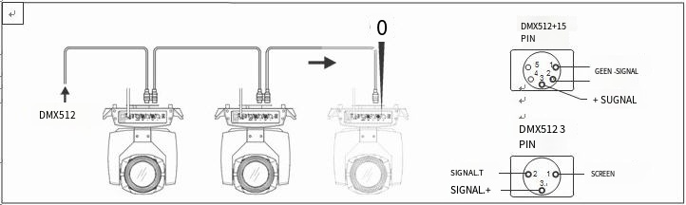
Figure 1 DMX signal connection diagram
- Lamps and lanterns is the starting address code calculation method:
Current lamps and lanterns, is equal to the starting address (a lamp in the starting address code) + (the channel number of lamps and lanterns) description:
1: first the starting address code value A001 of lamps and lanterns.
2: basic channel number of the controller, lamps and lanterns should be greater than or equal to the total use the channel number.
3: note: when using any of the controller, each table lamps and lanterns should be must have its own starting address code, if the first set A001 starting address code, of lamps and lanterns of lamps and lanterns, number is 16 ch; Then the second stage lamps and lanterns is the starting address code is set to A017; The third stage the starting address code is set to A033 of lamps and lanterns; So on, the mode (this setting can be according to different control table to decide)

  - Installation of lamps and lanterns
Lamps and lanterns can be placed, hang on and upside down. Hang on and upside down when it is important to note that the installation method.
As shown in figure 2, before the lamps and lanterns of positioning, to ensure the stability of the installation site, when the reverse hanging installation, lamps and lanterns must ensure that don't fell on the supporting frame, the need to use safety rope through the racks and auxiliary hanging lamps and lanterns of handle, in order to ensure safety,. To prevent the fall of lamps and lanterns and sliding.
When installing and debugging the lamps, pedestrians are prohibited to pass below. Check regularly whether the safety rope is worn and whether the hook screw is loose.
If because hanging installation is not stable, lead to consequences as a result of the fall of lamps and lanterns, our company does not undertake any responsibility.

The control panel

2.1 Key Instructions
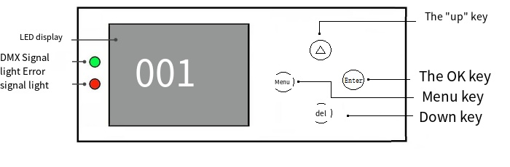

Figure 3 panel key schematic diagram
With the modified DMX address below as an example, about the use of keys:
1, if the current is not the main interface, press "menu" key (one or more) can be returned to the main interface
2. Under the main interface, press the "Up" or "Down" key to select the "Settings" button
3, press the "ok" key, enter the "Settings" interface
4, under the "Settings" interface, press "up" or "down" key to select "DMX address"
5, Press the "OK" key to enter the edit state
6. Press "Up" or "Down" to modify the DMX address code
7, press the "ok" key to exit the editor

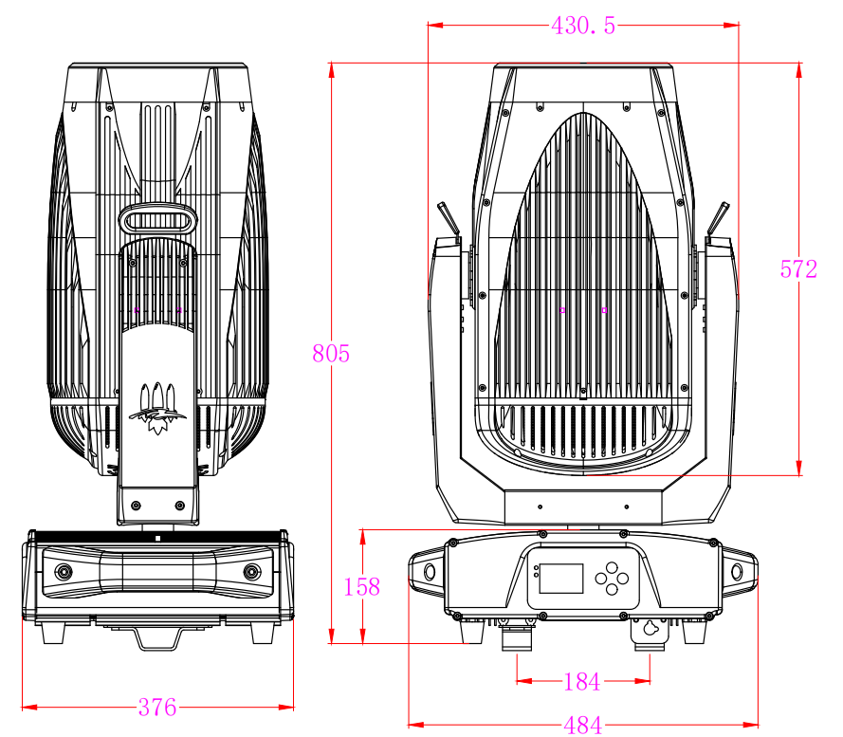

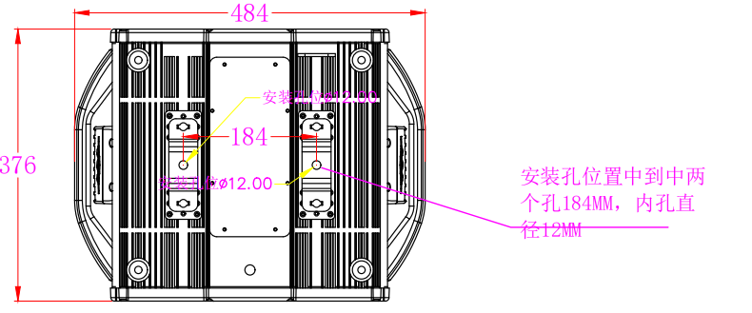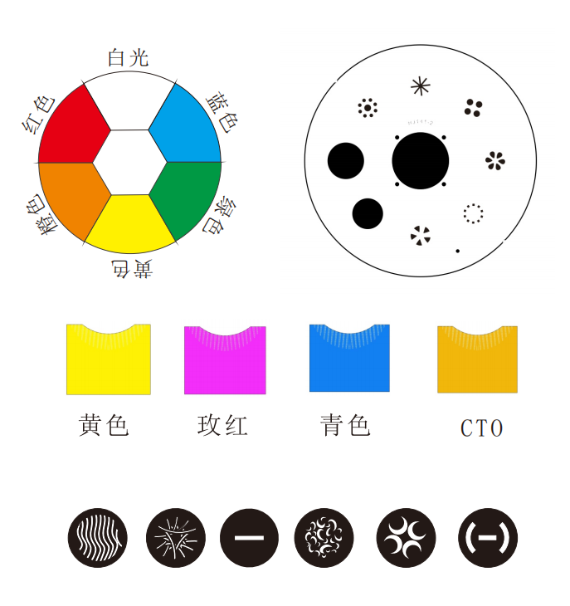

2.2 Menu Description
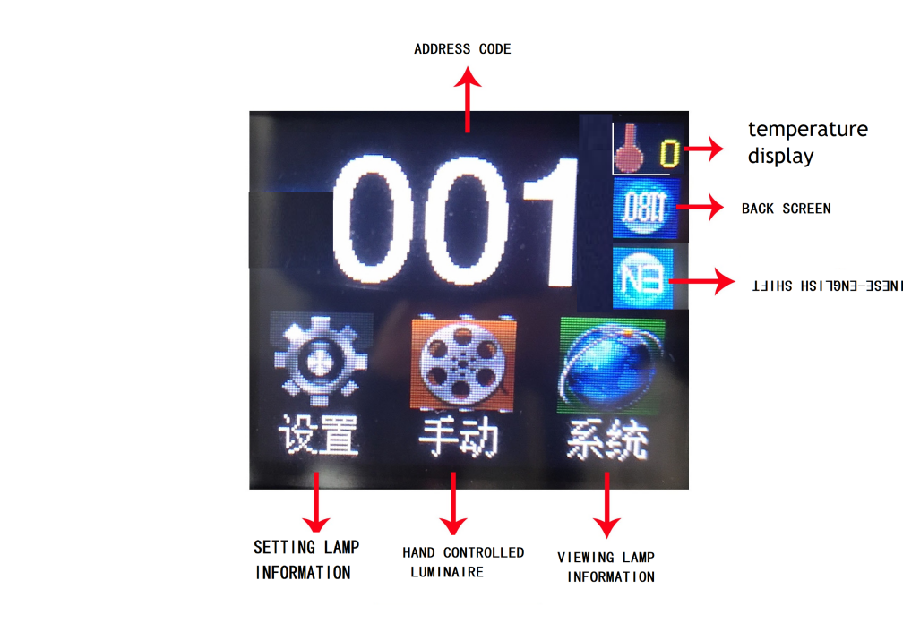
Schematic figure 4 main menu

2.2.1 manually
This interface is used to control the current lamp, and automatically enter the host state (do not receive DMX signal, send DMX signal to the bus to the slave).
Manual menu will according to the standards set by the Settings menu 21 channel
Options | instructions
1CH. | 0 ~ 255 | Press "ok" button to enter edit state. At this point is selected one hundred, press the "up" "down" key values change channels. Press "OK" again to select the ten digit edit. Press the "ok" button once again and select bits editor. Press one more time to exit edit status
... | 0 ~ 255
15CH. | 0 ~ 255
16CH. |  | Press "ok" after seeing confirmation dialog box, press the "ok" key once again, into the reset interface, reset all motor
21 ch. Reset

2.2.2 set
options | Notes
Run mode | DMX | Slave state: Receive DMX signals from console or host
 | Since the go | Host state: Self-walk and send DMX signal to slave
DMX address | 1-512 | Press "ok" button to enter edit state. At this point is selected one hundred, press the "up" "down" key to change the address code. Press the "ok" button once again and selected 10 editor. Press the "ok" button once again and select bits editor. According to the state of an exit the editor again
The channel model | 21CH | Standard 21 channel model
X inversion | Off
X inversion | On
Y-reversal | Off
Y-reversal | On
XY exchange | Off
XY exchange | On | The exchange of XY channels (including fine-tuning)
XY encoder | On | Using encoder (light coupling) judging out-of-step and automatically correct position
XY encoder | Off | Do not use the encoder (light coupling) correct position
DMX signal | keep | According to the original state continues to run
DMX signal | reset | The motor returns to position and stops running
Boot bright bubble | Off | After power on reset directly, not light bulb (menu or control table has to be used to manually light bubble)
Boot bright bubble | On | Electric light automatically after the bubble, and to wait for the light bulb lights up the success had only then to reset
Color wheel changes linearly | On | Color wheel changes linearly
Color wheel changes linearly | Off | Nonlinear change color wheel, a color change
The setting
Restore the default Settings |  | Click "ok" button after see confirmation dialog, press the "ok" key again to restore the default Settings

2.2.3 system
options | instructions
DIS |  | Display board software version
MT |  | Motor plate software version
Reset the calibration | The X axis calibration | After the child into the interface, it can adjust the reset of X axis and Y axis motor position, in order to make up for the error of hardware installation, adjustment range - 128 ~ + 127, + 0 means no adjustment.
Reset the calibration | The Y axis calibration
Reset the calibration | Color calibration
Reset the calibration | Gobo calibration
Reset the calibration | Gobo2 calibration
Reset the calibration | Gobo2 rotation calibration
Reset the calibration | Focusing calibration
Reset the calibration | The dimming calibration
Reset the calibration | Zoom calibration
Reset the calibration | Prism calibration.
Reset the calibration | Frost calibration
Reset the calibration | Gobo3 calibration
Sensors to monitor | X-axis Hall | 0 when magnetic is detected, 1 otherwise
Sensors to monitor | Y hall | When the detection to magnetic is 0, or 1
Sensors to monitor | Color hall | When the detection to magnetic is 0, or 1
Sensors to monitor | Design hall | When the detection to magnetic is 0, or 1
Sensors to monitor | Adjustable JiaoHuoEr | When the detection to magnetic is 0, or 1
Sensors to monitor | Enlarge Hall | When the detection to magnetic is 0, or 1
Sensors to monitor | Dynamic figure hall | It is 0 when magnetic is detected, and 1 otherwise
Sensors to monitor | Figure spin hall | When the detection to magnetic is 0, or 1
Sensors to monitor | The X-axis encodes the disk status | 2 digits, each corresponding coding dish in a photoelectric switch
Sensors to monitor | The Y-axis encodes the disk status | 2 digits, each corresponding coding dish in a photoelectric switch
Sensors to monitor | The X-axis encodes the disk step value | Were walking direction, step value should be increased, walking in the opposite direction, step value should be reduced. The value is normal every time you go to the same point
Sensors to monitor | Y code disc step value | The step value should increase when going in the positive direction and decrease when going in the opposite direction. Every time they go to the same point as to normal value
System error |  | If the ERR red light shine, lamps and lanterns is operation error, can enter the child interface for details. After the view can press "clear" the error record to empty
DMX Monitoring |  | Real-time monitoring and control signals

Error messages | Notes
MT plate connection | Motor plate didn't respond. Connect the display board and motor plate serial port communication line has a problem, or there is something wrong with the motor plate.
The X axis reset failed | X axis photoelectric switch, or X axis motor or board has a problem
Y axis reset failed | Y photoelectric switch, or Y axis motor or board has a problem
X-axis Hall error | The X axis hole, or there is something wrong with the motor plate
Y Hall error | Y hall, or there is something wrong with the motor plate
Failed color disk reset | Color plate hole, or color plate of motor has a problem
Pattern plate reset failed | Pattern disc hall, or there is a problem with the pattern disc motor
Focusing reset failed | Focus hall, or focus motor problem
The light bulb control failure | Failure to brighten or debubble. There is a problem with the lamp or bulb

Channel function

The channel table

channel | Channel pattern
channel | 21
1 | X
2 | X fine
3 | Y
4 | Y fine
5 | XY speed
6 | Dimmer
7 | Shutter
8 | C
9 | M
10 | Y
11 | CTO
12 | Color
13 | Gobo
14 | Gobo 2
15 | G0b02 rotating
16 | Prism
17 | Prism rotating
18 | Frost
19 | Focus
20 | Zoom
21 | Reset

Channel parameter values (full version) :
Channel | Features | Channel values | Effect
1 | X | 000-255. | The level of 540 degree scanning
2 | X fine | 000-255. | Level 1.2 degrees fine tuning
3 | Y | 000-255. | Scan at 270 degrees vertical
4 | Y fine | 000-255. | 1.2 degrees vertically
5 | XY speed | 000-255. | Speed from fast to slow
6 | Dimming | 000-255. | Brightness 100%
7 | Shutter | 000-003.  004-250.  251-255. | Brake light off  Stroboscopic from slow to fast  Brake light turn on (by the dimmer channel control)
8 | C | 000-255. | Linear switching
9 | M | 000-255. | Linear switched
10 | Y | 000-255. | Linear switching
11 | CTO | 000-255. | Linear switching
12 | Color | 000-119.  120-129.  130-139.  140-149.  150-159  160-169  170-210  211-255 | Linear switching  Color 1  Color 2  Color 3  Color 4  Color 5  Is water (from fast to slow)  Reverse flow, from slow to fast)
13 | Gobo | 000-009.  010-019.  020-029.  030-039.  040-049.  050-059  060-069.  070-079.  080-089.  090-099.  100-109.  110-119  120-129  130-139.  140-149.  150-200.  201-255. | White light  Gobo 1  Gobo 2  Gobo 3  Gobo 4  Gobo 5  Gobo 6  Gobo 7  Gobo 1 Shake(from slow to fast)  Gobo 2 Shake( from slow to fast)  Gobo 3 Shake(from slow to fast)  Gobo 4 Shake( from slow to fast)  Gobo 5 Shake( from slow to fast)  Gobo 6 Shake(from slow to fast)  Gobo 7 Shake(from slow to fast)  Reverse flow (fast to slow)  Is water (from slow to quick)
14 | Gobo 2 | 000-009.  010-019.  020-029  030-039.  040-049.  050-059.  060-069.  070-079.  080-089.  090-099.  100-109.  110-119.  120-129.  130-191.  192-255. | White light  Gobo 1  Gobo 2  Gobo 3  Gobo 4  Gobo 5  Gobo 6  Gobo 1 Shake (from slow to fast)  Gobo 2 Shake (from slow to fast)  Gobo 3 Shake (from slow to fast)  Gobo 4 Shake ,(from slow to fast)  Gobo 5 Shake ( from slow to fast)  Gobo 6 Shake ( from slow to fast)  Reverse flow, from slow to fast)  Forward flow (fast to slow)
15 | Gobo 2 rotation | 000-127.  128-191.  192-255. | 0-360 Angle rotation  Forward rotation (fast to slow)  Reverse spin (slow to fast)
16 | Prism 1 | 128-255.  000-127. | None  Prism 1 cut in
17 | Prism 1 Rotate | 000-127.  128-191.  192-255. | Prism Angle adjustment.  Reverse rotation (from fast to slow)  Forward spin (slow to fast)
18 | Frost | 000-127.  128-255. | None  Frost cut in
19 | Focus | 000-255. | Gobo clarity from far to near
20 | Zoom | 000-255. | Pattern clarity from far to near
21 | Reset | 000-025.  026-076.  077-127.  128-255. | None  Reset Effect  Reset XY  Reset All

4. Common faults and use attention

Common fault handling
The lamp contains microcomputer circuit board, high voltage power supply and other professional components, for your safety and product life, non-professional people should not disassemble the lamp and related accessories without authorization.

The light bulb is not bright
Possible reasons: The bulb is not completely cooled, or the bulb has reached its life expectancy, and the treatment is as follows:
- Because of abnormal operation, the bulb is not completely cooled, should let the lamp body cooling for more than 10 minutes, so that its internal completely return to normal state, and then start the power supply again;
- Check whether the bulb has reached its service life, and replace it with a new bulb;
- Check whether the light bulb and the light line leakage, falling off or poor contact;
- Replace the lamp with a new one.

The beam appears dim
Possible reasons: the bulb has been used for a long time or the light path is not clean, and the treatment is as follows:
- Check whether the bulb has reached its service life, and replace it with a new bulb;
- Check whether the optical components or light bulbs are clean, whether the dust is accumulated on the optical components such as light bulbs, and the light bulbs and components in the lamps need to be cleaned and maintained regularly.

Blurry pattern projection
- Check if the electronic focus channel value is appropriate for the present projection distance.

The light fixture works intermittently
Can cause: The internal line into the protection state, the treatment is as follows:
- Check whether the fan is running normally or whether it becomes dirty, causing the internal temperature of the lamp to rise;
- Check whether the internal temperature control switch is closed;
- Check if the bulb has reached its useful life and replace it with a new bulb.

The lamp will not accept the control of the console after it is reset normally
Possible reasons: signal line fault or abnormal setting of lamp parameters, the treatment is as follows:
- Check the start address code and check the DMX signal line connection (signal line cable is in good condition, set non head connection is loose);
- Add signal amplifier, plus 120 ohm terminal resistor;

Lamp can not start
Can cause: bad power line, the treatment is as follows:
- Check whether the insurance on the power input socket is fuse, replace the insurance;
- Lamps in long-distance transportation due to vibration caused by poor line contact
- Check the input power supply, computer board and other connected devices.

Precautions in use
- Check whether the local power supply meets the rated voltage requirements of the product, leakage protector, overcurrent protector, etc. meet the load requirements;
- Do not use the power cord with damaged insulation layer, and do not lap the power cord on other wires;
- Lamps use strong wind refrigeration, easy to collect dust, must be cleaned once a month, especially the cooling tuyelle, otherwise it will be blocked by dust, resulting in poor heat dissipation, so that the lamps appear abnormal.
- When installing the lamps, the fixing screws must be fastened, and with a safety cable, and regular inspection;
- When installing and positioning the lamps, any point on the surface of the lamps and any combustible explosive, maintain a minimum distance of 10 meters, 2.5 meters from the irradiation distance, please do not directly install the lamps on the surface of combustible substances;
- It is recommended that the continuous working time of the lamp should not exceed 10 hours, and the interval time of continuous starting the lamp should not be less than 10 minutes, otherwise it will not be triggered normally because of the overheating protection of the bulb;
- The closing time of the switch valve should not exceed 5 minutes. If you need to close the light for a long time, you should use the console (lamp control channel) to close the lamp;
- In order to ensure that multiple lamps better comply with the scene effect, the lamps should not have been in the current scene, that is, to start the next scene action, it is best not to exceed 3 minutes, to ensure that multiple lamps can run synchronously.
- During use, if the lamps are abnormal, stop using the lamps in time to prevent inducing other faults;

